Project Design Phase-II
Technology Stack (Architecture & Stack)
Date | 03 October 2026
Team ID | SWTID-2026-9936
Project Name | Auto Ticket Classification using Flow Designer
Maximum Marks | 4 Marks
Technical Architecture:
The Deliverable shall include the architectural diagram as below and the information as per the table1 & table 2

Architecture: Auto Ticket Classification using Flow Designer
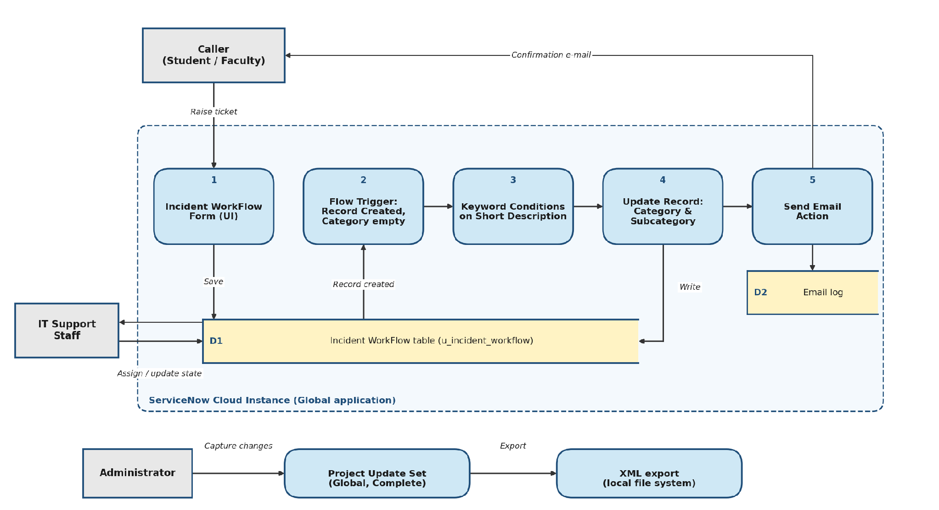
Flow: (1) the caller raises a ticket in the Incident WorkFlow form and it is saved in the table. (2) The flow triggers on record creation when Category is empty. (3) Keyword conditions check the Short Description. (4) The record is updated with Category and Subcategory. (5) A confirmation email is sent to the caller and logged. IT support staff work on the classified tickets, and the administrator captures all changes in the Project Update Set and exports it to XML.

Table-1 : Components & Technologies:
S.No | Component | Description | Technology
1. | User Interface | Incident WorkFlow form where the caller enters Caller, Short Description and Description; Category and Subcategory are filled automatically | ServiceNow Platform UI (Form view, Form Design)
2. | Application Logic-1 | Auto classification: the flow 'Auto Classify School IT Tickets' runs on record creation when Category is empty and sets Category and Subcategory from keywords (Wi-Fi / Network, Projector, Password, Slow) | ServiceNow Flow Designer (Record Created trigger, If conditions, Update Record)
3. | Application Logic-2 | Dependent choice logic: Subcategory choices are filtered by the selected Category (Wi-Fi > Network, Projector > Hardware, Forgot Password > Access, Slow Computer > Performance) | Dictionary attribute 'Use dependent field', Table Designer
4. | Application Logic-3 | Email notification: sends 'Your Request for the issue has been submitted.' to the Caller's email when a ticket is submitted | Flow Designer Send Email action, ServiceNow Email (sys_email)
5. | Database | Custom table Incident WorkFlow (u_incident_workflow) with Number, Caller, Category, Subcategory, Short Description, Description, State, Assigned group and Assigned to | ServiceNow platform database (custom table)
6. | Cloud Database | The table is stored in the ServiceNow cloud instance and is managed by the platform | ServiceNow cloud instance (dev207239)
7. | File Storage | The completed Update Set is exported as an XML file for deployment | Local file system (Update Set XML)
8. | External API-1 | Not used. The solution runs fully inside the ServiceNow platform | Not applicable
9. | External API-2 | Not used | Not applicable
10. | Machine Learning Model | Not used. Classification is rule-based keyword matching on the Short Description | Not applicable (rule-based logic)
11. | Infrastructure (Server / Cloud) | Application deployment on a cloud instance. Local server configuration: not required, a web browser is enough to access the instance. Cloud server configuration: ServiceNow developer instance, Global application scope, changes tracked in the Project Update Set | ServiceNow Cloud, Local Update Sets
Table-2: Application Characteristics:
S.No | Characteristics | Description | Technology
1. | Open-Source Frameworks | No open-source framework is used. The solution is built with ServiceNow's built-in low-code tools | ServiceNow Flow Designer, Table Designer, Form Design, Update Sets
2. | Security Implementations | Users must log in to the instance, access to the table and flow is controlled by ServiceNow roles and access controls, and every configuration change is tracked in an Update Set | ServiceNow authentication, Role-based access control (ACL)
3. | Scalable Architecture | Rule-driven design: new categories, subcategories and keyword conditions can be added in Flow Designer without scripting, and the instance is hosted on the ServiceNow cloud platform | ServiceNow Flow Designer, ServiceNow cloud platform
4. | Availability | The application is hosted on the ServiceNow cloud, so there is no local server to maintain and tickets can be submitted whenever the instance is running | ServiceNow cloud instance
5. | Performance | The flow runs automatically on record creation and uses simple 'contains' conditions on the Short Description, so classification and email dispatch happen immediately without manual triage | Flow Designer triggers and conditions
References:
https://c4model.com/
https://www.ibm.com/cloud/architecture
https://aws.amazon.com/architecture
https://medium.com/the-internal-startup/how-to-draw-useful-technical-architecture-diagrams-2d20c9fda90d

